|  |
| --- |
| Purdue University |
| Augmented Reality Simulator |
| A multi-user augmented reality simulator with heads-up display |

|  |
| --- |
| Stephen Carlson, Steven Ellis, Thor Smith |

**Table of Contents**

Project Summary 2

Challenge Definition 2

Proposed Solution 3

Performance Measures 6

Timeline and Milestones 7

Feasibility and Resources Available 8

Potential Concerns and Alternative Plans 9

Works Cited 10

## Project Summary

Wearable computing is quickly becoming the next step of embedded systems evolution. A revolution which began with smartphones has progressed to devices like Google Glass and the Samsung Galaxy Gear aimed to bring computing closer to everyday life. But existing wearable implementations target the consumer market and intend to serve as merely omnipresent gateways to the Internet of Things. As a solution, this team proposes an augmented reality platform which offers new multi-user collaborative applications for wearable computing.

To provide this functionality, sensor fusion of geospatial position and inertial measurements will allow the device to determine the user’s location and head orientation for applications such as driving directions or virtual tours. A team-designed power management system will be used to maximize battery life. Wireless connectivity and a user interface designed for wearable computing will also be critical for integration with other headsets. This device aims to minimize disruption of the user’s peripheral vision while also avoiding the eyestrain of constant visual refocusing. The device will eventually be tested both indoors and outdoors to ensure adequate visibility in a range of lighting conditions and user-friendliness for a non-technical audience.

## Challenge Definition

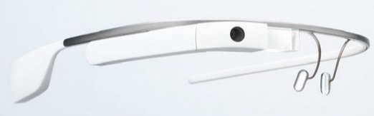Wearable computing is quickly becoming the next step of embedded systems evolution. Devices like Google Glass [1] as shown in Figure 1 and the Samsung Galaxy Gear aim to make computing part of everyday life. However, existing wearable devices are designed to serve as omnipresent gateways to the Internet and are not intended to work together in a collaborative real-time application with multiple users. As an alternative, this team proposes an immersive augmented reality platform which offers new multi-user applications for wearable computing. Such a device would have broad applications in education, defense, group recreation, and artistic performances where small teams of users can work together in the same augmented reality environment.

Figure : Google Glass, an existing wearable computing product

Portability and ergonomic challenges will primarily influence project development, as competing devices are often chosen for small size and low power consumption. A good solution to this challenge must have long battery life and a low mass to promote long-term wearable usage patterns. The virtual environment will not replace the real environment, so an ideal solution must also allow the user to perceive the real world with minimal eye strain or peripheral vision obstruction. Since augmented reality systems aim to overlay objects onto real-world positions, a successful device must be able to determine the position and orientation of the user in three-dimensional space within at least a few meters of precision.

This device must be capable of wireless communication with other augmented reality devices in close proximity to enable multi-user applications, where more than one user can share the same virtual environment. From a user perspective, ergonomics are also a major concern for wearable devices; the challenge is incorporating the desired functionality while not creating an unnecessarily heavy or bulky device. A successful device must also be durable enough to withstand regular use while not requiring technically experienced users for support.

While the software to support an augmented reality application will be dependent on the eventual usage case, the operating system which configures the headsets and handles common functionality like wireless networking and sensor processing must be easy to set up and use. For a non-technical user to understand the device, the application must start automatically on power up and walk the user through any initial setup process such as wireless pairing or sensor calibration. Custom applications which are written for this device should maintain a consistent state across any and all participating users and update the displayed virtual world at timely intervals.

## Proposed Solution

The proposed solution approach to this challenge focuses on the sensing and peer communication aspects of the challenge. This project’s scope will not include Internet connectivity, computer vision, or an external user input device to increase the feasibility of the primary constraints.

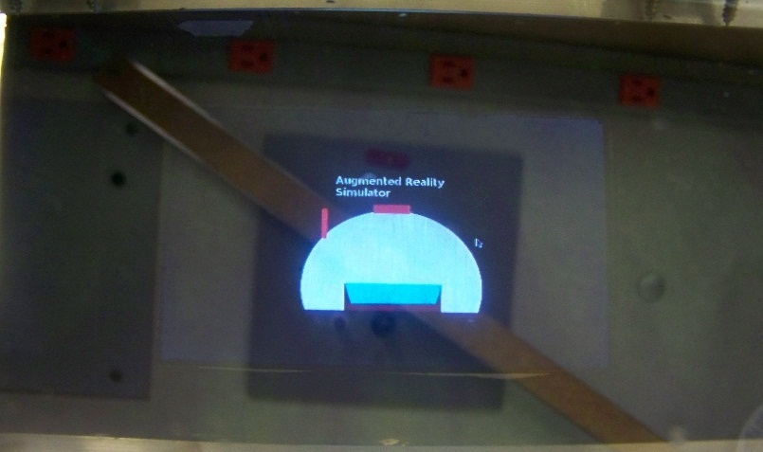

Figure : View from display of current prototype showing a custom promotional graphic

The solution to the project is divided into two phases. The first phase will focus on getting a preliminary prototype working, and the second phase will focus on adding the Intel development board to finalize the design and allow for a second iteration. An image of the prototype for the first phase is shown in Figure 2. The proposed augmented reality system will take the form of a head-mounted device which overlays virtual objects onto a semi-transparent panel suspended in front of the user’s eyes. Applications can select exactly what information is displayed, but typical virtual objects might include waypoints, signs, or non-player characters. Virtual objects will be wirelessly coordinated between any collaborating devices to allow multiple users to share the same environment, addressing the key limitation of most existing solutions. Battery power will be used for the whole device to permit untethered operation and satisfy the challenge requirement for portability.

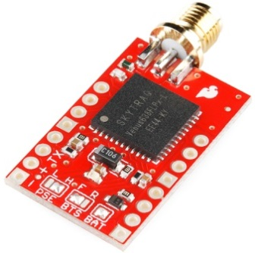A central component of the system is the virtual display device. Commercial transparent displays are cost prohibitive, so the device will utilize a regular LCD screen which will project the virtual image onto a partially mirrored surface, combining the image and the environment. This design minimally affects peripheral vision and depth perception, as opposed to some existing approaches which overlay the images in software on a digital image of the environment. An optical collimation system, whose theory of operation is still to be determined, will be used to make the image appear focused far away. This adjustment allows simultaneous focusing of the environment and the virtual image, to satisfy the challenge requirement for minimal eye strain.

Sensing components are also a key aspect of the augmented reality system. User position and velocity will be gathered by the Venus638FLPx GPS module shown in Figure 3 [2], while the three-axis orientation of the user’s head will be determined via a nine degree-of-freedom combination accelerometer, gyroscope, and digital compass (L3GD20 and LSM303DLHC) [3]. Sensor fusion of these three inputs will determine a more accurate estimate than any individual sensor can provide, to address the challenge of determining the user’s geospatial location and orientation. A battery management sensor will also be incorporated to provide a reliable estimate of remaining battery power.

Figure : Venus638FLPx GPS module used to determine user location

An Intel Atom motherboard will be used to handle application functions including graphics rendering and data processing. A lithium-ion battery will be used to power the headset to satisfy the requirements of portability. These two components are heavy enough to make the headset unwieldy, so they will be relocated to another enclosure worn by the user. As the inertial measurement unit and GPS require placement on the user’s head to measure the direction the user is actually looking, these parts will remain on the headset, and will be connected via a custom designed PCB to the motherboard. Initially, the competition provided Intel Atom board will be used for prototyping [4], but another board with lower power consumption and mass may be selected in the future to meet the design targets shown in Performance Measures. All these components will interact as shown in Figure 4.



Figure : Functional block diagram of major software and hardware components

Graphics rendering and data processing software will be ported from phase 1 of the design, an initial iteration which uses a Raspberry PI Model A for graphics processing and an STM32F4 for sensor data collection as shown in Figure 4. This code will be re-used on the Intel Atom motherboard in phase 2 and enhanced for better usability and graphics performance. In phase 1, another Raspberry PI Model A acting as a central control unit (CCU) is used to run simulations and communicate the locations of virtual objects wirelessly to the headsets. In phase 2, the central control unit will be integrated into the headset software, allowing one headset to function as the control unit for a given application which must remain operational for the duration of the simulation. Figure 6 shows the operation of the current central control unit. The simulation logic in that process will perform actions such as updating the positions of virtual objects through the connected XBee wireless module.

The intended application of our system is gaming. The only user inputs available in this design are the location and head orientation available from the GPS and IMU sensors, so this restricts the types of games that are feasible to those that follow the basic format of tag, in which collisions between players or virtual objects are the only way for the user to interact with the virtual world. Hence the initial target application to be developed for the system will be a 3D Pacman-like game.



Figure : Block diagram of current phase I headset and central control system

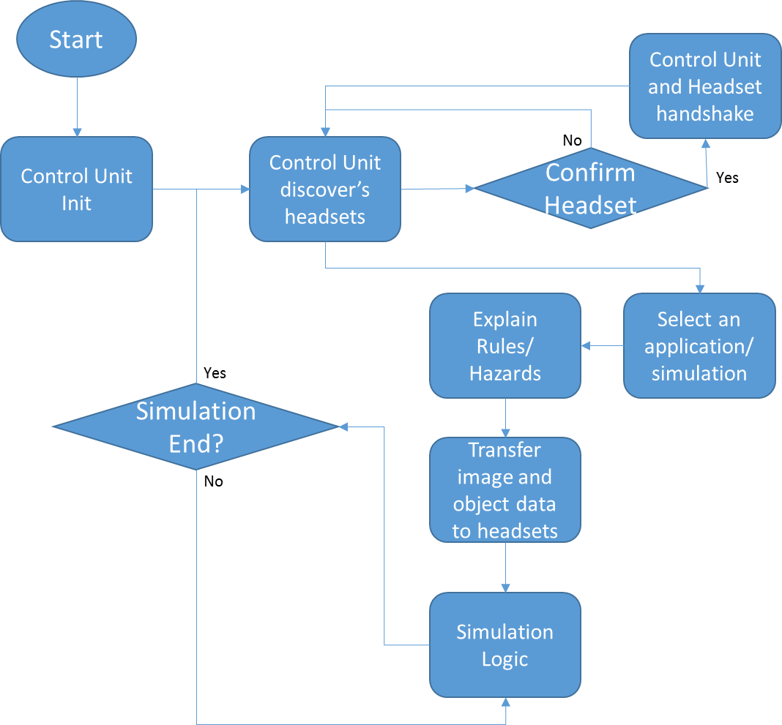

Figure : Flow chart showing the phase 1 control unit’s logic, which will extend to the controlling headset in phase 2

Figure 7 shows the states that the headset will go through as the simulation logic proceeds from the central control unit. Each headset will begin by advertising its presence when turned on. The control unit will send a packet to indicate that the headset has been accepted in the simulation. After being accepted, the headset will wait for image and object data from the control unit. Image data is sent only once because there is limited bandwidth available during the simulation which will be used for sending updates about user position and the position of ghosts and other virtual objects. Next, the control unit will send a message transitioning the headset into the simulation state, where it will broadcast its GPS position and IMU orientation. The control unit will send periodic updates to the headsets to update the condition of the virtual environment. This display information, the user’s current position, and the user’s head orientation are fed from the STM32F4 to the Raspberry PI that is handling the graphics, along with the wireless connection information and battery status.

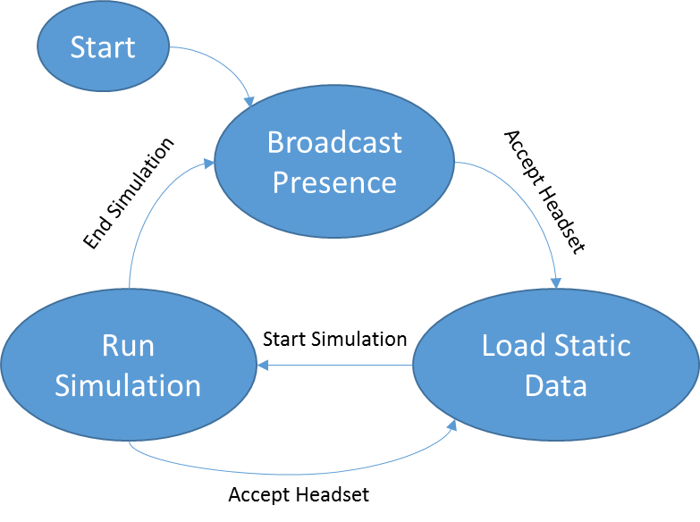

Figure : State machine showing the flow of states driven by packets from the control unit

At the Intel Cornell Cup demonstration in May 2013, this project expects to have a fully functional augmented reality display which can overlay virtual objects onto the environment with respect to the user’s position and orientation. The device will also be able to wirelessly participate in the same virtual environment with another prototype headset, and will be capable of operating on battery power inside a complete package with a sample application running.

## Performance Measures

The experience of the end user will determine the satisfactory completion of the challenge, so frequent testing will be performed at multiple stages of the design to incorporate feedback from non-technical users. Project success will primarily be measured by the criteria shown in Table 1. Table 2 shows performance metrics specifically targeted towards software.

Table : Augmented reality system performance measures and satisfactory design metrics

| Metric | Target | Description |
| --- | --- | --- |
| Mass | Headset: 1 kg  Backpack: 3 kg | Neither the headset nor the backpack can be too heavy to impede the performance of typical activities by the user. |
| Power | 3 hours runtime | Augmented reality applications run for long durations, so the device must operate long enough on battery power to be usable. The remaining battery capacity should be displayed to the user. |
| Location | Minimum 2 meter accuracy and precision | The accuracy of the rendered virtual world depends heavily on the accuracy and precision of the user’s geospatial position. |
| Wireless | 80 m range, line of sight | A unique feature of this device is the wireless coordination capability of multiple headsets in the same virtual environment. The current wireless signal strength should be reported to the user. |
| Comfort | No running speed or vision reduction | Ideally, the user would be able to perform actions without a noticeable burden on the user. It is difficult to quantitatively measure comfort, but the user should be able to orient their head, see the environment, and move from place to place as effectively as if the device was not worn. |
| Durability | Operate from 0 to 40 C indoors and outdoors in dry conditions | Most augmented reality applications involve users walking or running, which will subject the device to vibration and light impacts. In addition, sunlight, humidity, and dust are inherent concerns for a portable device. |
| Usability | End user can start up and use device without a technician | A user unfamiliar with the device technical details must be able to power on the device, perform start-up procedures such as wireless connection, and load the desired application. |

Table : Augmented Reality Software Performance Metrics

| Metric | Target | Description |
| --- | --- | --- |
| 3D Graphics | Minimum 5000 polygon count | The user will expect to see a good 3d image. Phase 2 offers opportunities to increase graphical performance. |
| Graphics | Minimum 20 Hz update rate | We will need to render ghosts and the maze walls in real time according to the user’s geospatial location and their head orientation. |
| Collision Detection | Minimum 2 meter accuracy and precision | The ability of the software to detect collision detection will be affected by the accuracy of the GPS. The minimum required to be meaningful cannot exceed a couple of meters. This means ghosts could be 2 m2 to account for accuracy of GPS. |
| Network  User Position Update Rate | Minimum of 20Hz (50ms). | The position and orientation of each headset will need to be communicated wirelessly at least every 50ms to keep up with the GPS and provide meaningful feedback about collisions to each headset. |
| Network  Graphic Position Update Rate | Minimum of 20Hz  (50ms) | The position information about positions of ghosts and other virtual objects needs to be updated in a timely manner and should at least be as fast as the update rate of the player’s position. |
| User Interface Usability | End user can navigate the user interface intuitively. | A user unfamiliar with the operation of the software should be able to figure it out with minimal references to the user manual. For phase 1 this will be displayed from the control unit. In phase 2 the user interface will migrate to the headset’s display. |

## Timeline and Milestones

The timeline and milestones can be seen in the accompanying spreadsheet, which has two sheets. One sheet keeps track of individual tasks, the time to complete the task, how the task depends on other tasks, and what deliverables are expected from the task. The other sheet has tasks mapped to dates, which are grouped into categories. These categories have been chosen because they logically separate pieces of the design and separate tasks that different team members are expected to accomplish. Multiple schedules are overlapped with each other to demonstrate which parts of the project members can complete simultaneously.

The timeline is divided into two sections denoted as phase 1 and phase 2. Phase 1 refers to the first iteration of the project which is being implemented for a senior design project. This iteration will help in making the team familiar with the hardware and software that will be developed for the final project design, including sensor filtering and device interfacing. This means that a phase 1 prototype of the project will exist by the end of November, which will not have Intel hardware due to its focus on low cost and demonstrable functionality. Phase 2 will focus on enhancing user graphics, fixing any system implementation issues from phase 1, and enhancing the end user experience through refined packaging design and user feedback. Once phase 1 is completed, the amount of time required for tasks in phase 2 and its hardware details will be finalized.

## Feasibility and Resources Available

The feasibility study for this device begins with a previous Cornell Cup entry, the Incredible HUD [5]. This 2012 entry from Purdue University displayed status information to the user, such as temperature, speed, and time, on a heads-up display mounted inside a motorcycle helmet. It utilizes a similar optical principle of operation as the proposed augmented reality design. Since the Incredible HUD was constructed on the same time constraints as the proposed design, the proposed optical display technology appears to be very feasible.

Another example more oriented towards augmented reality was the ARQuake system, constructed by several graduate students in 2006 at the University of South Australia [6]. This device allowed users to play the video game Quake in an augmented reality environment using semi-transparent vision goggles. At that time, an acceptable representation of a virtual reality system was produced with costly sensing systems inferior to modern devices. Technological advances in the last six years, especially in consumer grade GPS [2] and inertial measurement units [3], will make it even more feasible to integrate lower-cost sensor equivalents today into this project.

Due to the early start of this project in developing a first design iteration for a senior design project as shown in Timeline and Milestones, some functionality is already complete as evidenced by the team website [7]. The GPS unit and inertial measurement unit have already been procured, and code to read their values has already been prototyped and confirmed to work. Much of the graphics code developed in the next few months will also be portable to the Intel Atom platform. Intel Atom motherboards already on hand [4] will allow the software development team to start these modifications early, before the second iteration of hardware design changes is completed. Early display hardware and packaging has also been developed to evaluate mechanical feasibility, with initial CAD models as shown in Figure 9 and a prototype headset design as shown in Figure 8. Trials of this prototype have been encouraging, leading the team to believe that hardware integration is definitely feasible.

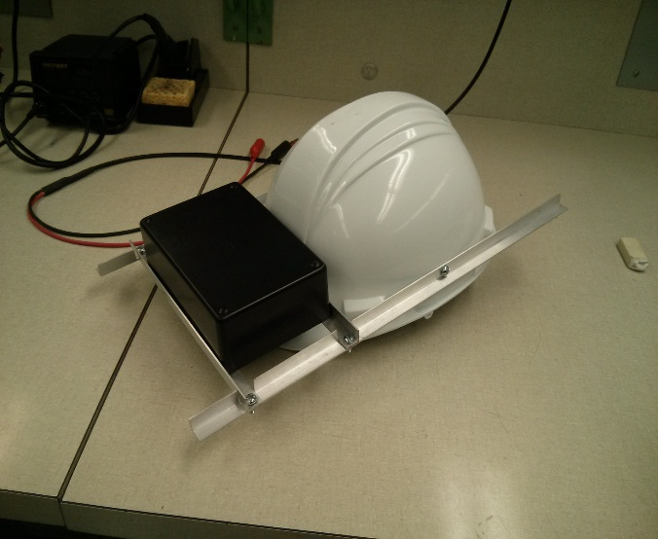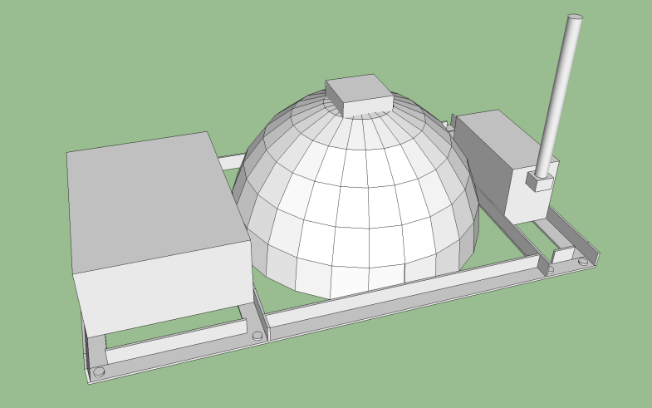

Figure 8: Image of current design prototype (without reflective plate attached)

Figure : Preliminary CAD drawing of Phase 1 prototype

## Potential Concerns and Alternative Plans

There are several potential concerns with our current plans for implementing the project. The accuracy of the GPS unit, while very good for a consumer unit, may prove to be insufficient for a convincing augmented reality experience. The ARQuake system suffers from noticeable jitter due to GPS accuracy, particularly when virtual objects are nearby. Advanced processing techniques using carrier phase measurement or the accelerometer data can be applied to the GPS to increase accuracy while still using low cost hardware if needed, running on the Atom using software such as the open source library RTKLIB [8]. Another potential problem is an inability of the user to focus simultaneously on the display and environment due to the close proximity of the display to the eyes. If needed, the mechanical design can be modified to incorporate collimating lenses to increase the apparent distance of the display, or it can be moved physically farther from the eyes.

Works Cited

|  |  |
| --- | --- |
| [1] | M. I. Olsson, M. J. Heinrich, D. Kelly and J. Lapetina, "Wearable device with input and output structures". United States of America Patent 20130044042, 18 August 2011. |
| [2] | SkyTraq Corporation, "Venus638FLPx GPS Receiver," January 2011. [Online]. Available: http://dlnmh9ip6v2uc.cloudfront.net/datasheets/Sensors/GPS/Venus/638/doc/Venus638FLPx_DS_v07.pdf. [Accessed 1 October 2013]. |
| [3] | SGS-Thomson Microelectronics, "L3GD20 and LSM303DLHC 9-axis module for a standard DIL socket," November 2011. [Online]. Available: http://www.st.com/st-web-ui/static/active/en/resource/technical/document/data_brief/DM00041389.pdf. [Accessed 29 August 2013]. |
| [4] | Terasic, "DE2i-150 FPGA Development Kit," [Online]. Available: http://www.terasic.com.tw/cgi-bin/page/archive.pl?Language=English&CategoryNo=11&No=529. [Accessed 14 October 2013]. |
| [5] | A. Balasubramanian, N. Sareshkumar, B. B. Gardner and M. Leone, "The Incredible HUD," Purdue University, 2012. [Online]. Available: https://engineering.purdue.edu/ece477/Webs/F11-Grp03/index.html. [Accessed 11 October 2013]. |
| [6] | B. Thomas, B. Close, J. Donoghue, J. Squires, P. De Bondi, M. Morris and W. Piekarski, "ARQuake: An Outdoor/Indoor Augmented Reality First Person Application," in *Proceedings of the Fourth International Symposium on Wearable Computers*, Atlanta, 2000. |
| [7] | S. Carlson, S. Ellis, A. S. Green and T. Smith, "Team 5 Website: Augmented Reality Project," Purdue University, 2013. [Online]. Available: https://github.com/snowpuppy/augreality/wiki. [Accessed 22 September 2013]. |
| [8] | "RTKLIB: An Open Source Program Package for GNSS Positioning," 2013. [Online]. Available: http://www.rtklib.com/. [Accessed 16 October 2013]. |



Mark C. Johnson

School of Electrical and Computer Engineering

Purdue University

465 Northwestern Avenue

West Lafayette, IN 47907-2035

Phone: (765) 494-0636